Turnkey Projects

 We undertake projects that pertain to parameters as discussed below to fully design, construct and equip all environmental service facilities that include water, wastewater, sewage treatment plants, common effluent treatment plants and solid waste management. Ecovision Smart India Pvt Ltd design, construct the project and delivers to the client when it is ready for operation and we also assist in operation and maintenance.

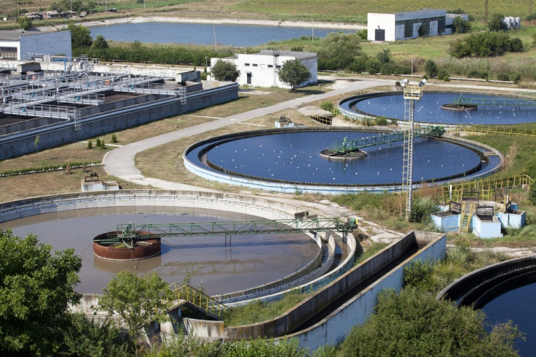

Water Treatment Plants

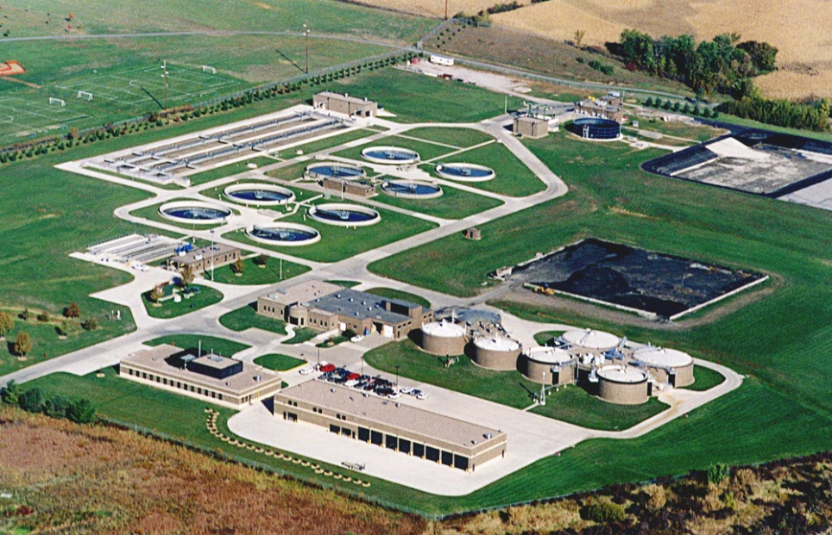

Waste water Treatment Plants

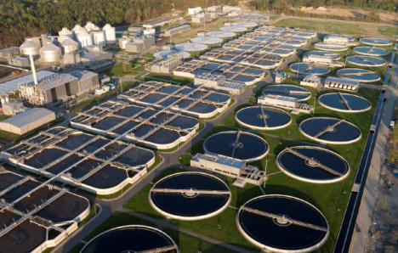

Common Effluent Treatment Plants

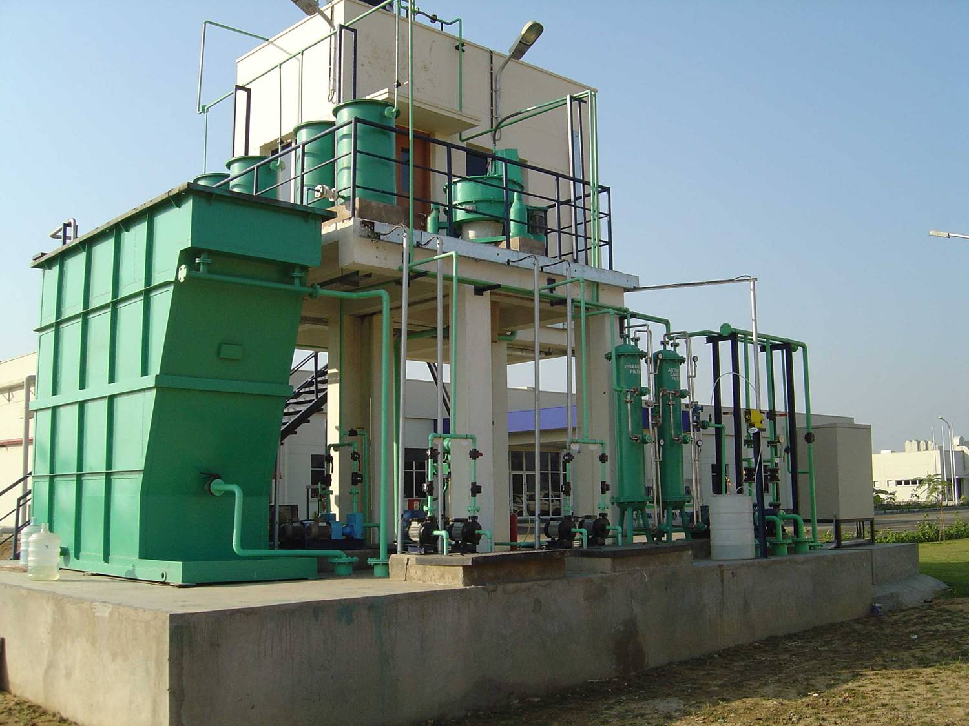

Sewerage Treatment Plant